Ortiz Guzman, Julio

11 October, 2021

ECe 3200-01 Lab 7

AC Coupled Multi-Stage Amplifier

**Objective:**

Design a Common-Emitter / Common-Collector amplifier to meet the purpose of having an amplifier with a **moderate** gain and a **low** output resistance.

**Prelab:**

**Procedure:**

1. Construct the circuit shown below using 2N3904 transistors.

Fig 1.

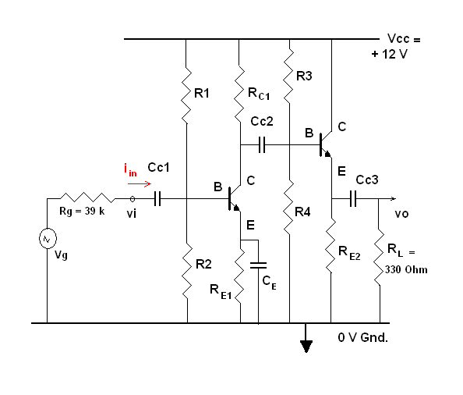

1. Measure the voltage gain vo / vi = Av with and without the load resistor.

Av(RL = ∞) = 4.408, Av(RL = 330) = -0.337

1. Measure the output resistance. ro = 330 Ω
2. Measure the input resistance Rin = vi / iin = 1.79 kΩ (RL = ∞)

Rin = vi / iin = 1.83 kΩ (RL = 330 Ω)

**Conclusion:**

This lab brought together the applications of the previous two labs into one. As a result of this lab, I was able to better understand how to design an AC coupled Multi-stage Amplifier. More specifically, the circuit shown in Fig 1. consisted of a Common-Emitter and a Common-Collector amplifier to produce a moderate gain and a low output resistance. Although I was not able perform the lab physically, I was still able to visualize and understand the circuit with the help of PSpice, and the zoom meeting provided. It was interesting to see the waveforms produced and how specific additions to the circuit changed the output waveforms.